C4 Level 1System Context Diagram

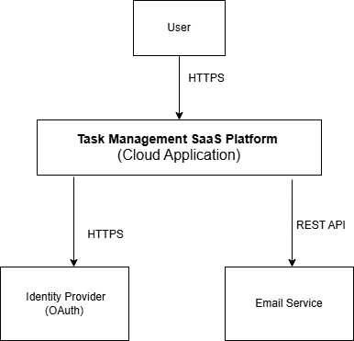

Description
- Users interact with the SaaS platform via browser or mobile.
- Authentication is handled by an external Identity Provider.
- Notifications are sent via an external Email Service
Technologies & Protocols
- Users → System: HTTPS (REST API / Web App)
- Auth: OAuth2 / OpenID Connect (via Auth0 or Firebase)
- Notifications: SMTP / REST (SendGrid / AWS SES)

C4 Level 2 – Container Diagram

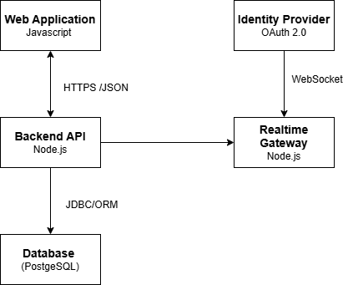

Description
Shows the major deployable containers and how they communicate.
- The Web Application (React) runs in the user’s browser and provides the interface for logging in, creating projects, assigning tasks, and viewing task progress.
- The Web Application sends all standard requests to the Backend API using HTTPS with JSON.
- The Backend API (Node.js) contains the core business logic, validates requests, enforces security rules, and coordinates all system operations.
- User authentication and authorization are delegated by the Backend API to an external Identity Provider via OAuth 2.0 / OpenID Connect.
- All persistent data such as users, projects, and tasks is stored in a managed PostgreSQL database, accessed only by the Backend API using SQL.
- For real-time updates, the Web Application opens a WebSocket connection to the Realtime Gateway.
- The Realtime Gateway pushes task status changes to connected users as soon as they occur.
- Each container is independently deployable, stateless, and hosted on a PaaS platform, supporting scalability and twelve-factor principles.

Component | Technology | Protocol
Frontend | React / Angular | HTTPS
Backend API | Node.js (Express) | REST/JSON
Database | PostgreSQL | JDBC / ORM
Auth Provider | Auth0 / Firebase | OAuth2/OIDC
Email Service | SendGrid / AWS SES | SMTP / HTTPS

C4 level 3 - Component Diagram
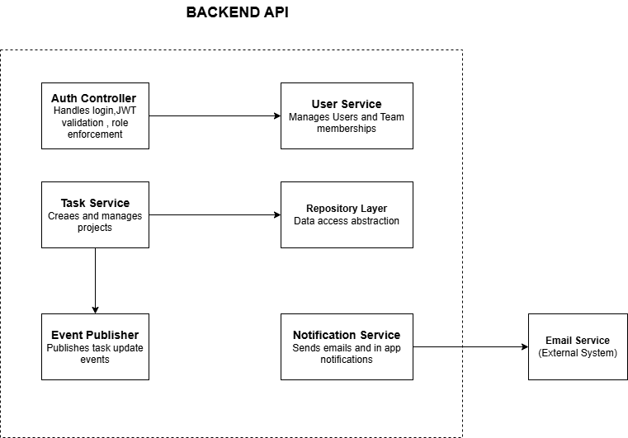

Component Diagram – Backend API Description
The Backend API is implemented using a framework such as Node.js (Express) or Spring Boot and is structured into multiple components that follow separation of concerns and support scalability, maintainability, and security.

1. Auth Controller
- Handles user authentication and authorization
- Validates JWT tokens
- Enforces role-based access control (RBAC)
- Acts as the entry point for secured requests
- Communicates with → User Service
2. User Service
- Manages user accounts and team membership
- Handles:
  - User registration
  - Profile management
  - Team assignments
- Provides user data to other components

3. Project Service
- Responsible for project lifecycle management
- Handles:
  - Creating projects
  - Updating project details
  - Managing project ownership
- Interacts with → Repository Layer to persist data

4. Task Service
- Core business logic for task management
- Handles:
  - Task creation
  - Task assignment to users
  - Task status tracking (e.g., To-do, In Progress, Done)
- Interacts with:
  - Repository Layer (for database operations)
  - Event Publisher (for real-time updates)
5. Repository Layer
- Provides data access abstraction
- Uses technologies like:
  - JPA / Hibernate (Java) or
  - ORM libraries (Node.js)
- Responsible for:
  - CRUD operations
  - Database communication (SQL)
- Ensures separation between business logic and persistence

6. Event Publisher
- Publishes task-related events such as:
  - Task created
  - Task assigned
  - Task updated
- Sends events to a Message Broker (e.g., Kafka or RabbitMQ)
- Enables:
  - Real-time updates
  - Loose coupling between components

7. Notification Service
- Handles user notifications
- Sends:
  - Email notifications
  - In-app alerts
- Communicates with:
  - External Email Service via SMTP or REST API

Technologies & Protocols Used
- REST API over HTTPS → client communication
- JWT → authentication
- SQL (PostgreSQL) → data persistence
- AMQP (RabbitMQ) / Kafka Protocol → event streaming
- SMTP / HTTPS APIs → email delivery

